Game Design Document – Out of Sight

Concept
Out of sight is an adventure puzzle game about a photographer who has been diagnosed with Degenerative Myopia. The player needs to navigate their nightmare using their camera as an extension of their vision. They must use their camera to solve puzzles as the camera can see things that the player cannot.
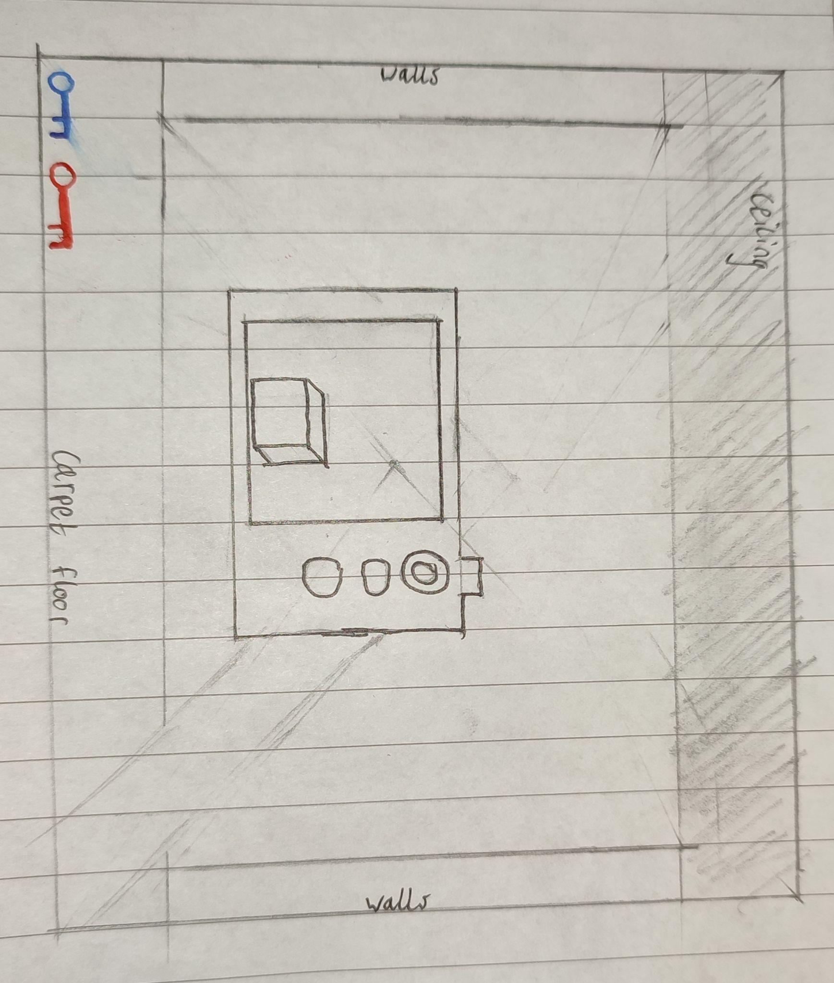
^Game Frame featuring a rudimentary HUD (all that’s really necessary for this game is an indicator of any collected keys. Also features the camera.

Narrative/Story
The main character has been diagnosed with degenerative myopia, causing him to lose most of his sight. Since the character is a photographer this is quite a big deal for him, but he's been assured he still has some time left with his vision. At the beginning of the game the player wakes up as, however he has lost most of his sight, this is abnormal as the player was told they still have some time left. When they walk out of their room they walk into a strange hotel that does not quite abide by the laws of physics. The implied narrative here is that by the end of the game, the player has conquered lots of puzzles and challenges with their lack of sight, proving to the main character that they do not need their vision to conquer life.
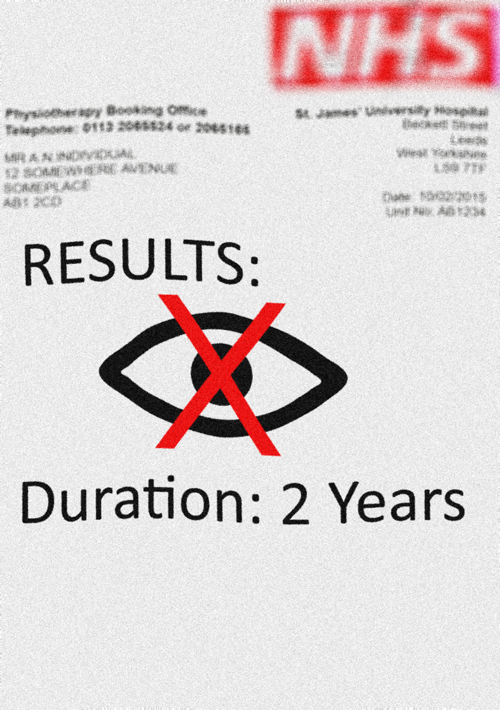

Themes
This is a game about hardship and challenges. The game focuses on the hardships that the player must go through to come to terms with their diagnosis. However, towards the end there will be themes of optimism as the player conquers their challenges and hardships.

Visual Style
The visual style of the game will be low poly and block colours with a simple gradient applied to all of the models. This is a simple yet effective look meaning we can focus on the gameplay throughout the game.

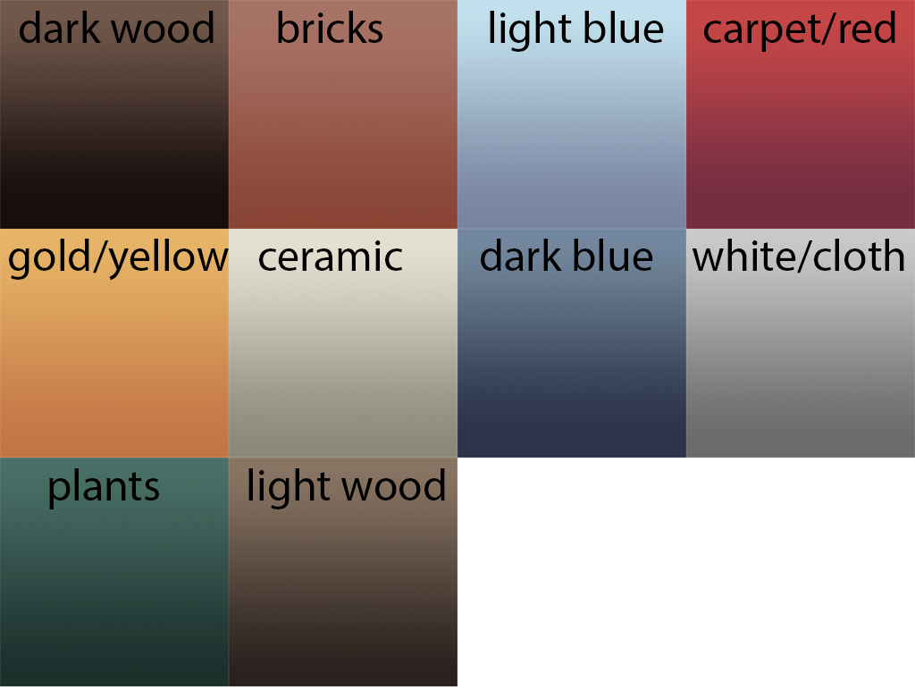
Gradients designed by Game Artist Sam Crookes.

Characters
Main Character - A photographer recently diagnosed with a degenerative condition that is taking away his eyesight.

As this is a 1st person game no character model will be necessary.

Mechanics
Physics Pick-up: Similar to handling of objects in games like Amnesia and Portal, it allows you to pick up certain objects in the game.
Camera: A supplement to your poor eyesight, allows you to see things further away than usual by taking pictures as well as revealing the secrets of the hotel.
Puzzle unique mechanics: Pressure plates that are activated when a prop or the player is in contact with them.
Moving platforms: with set paths that they follow that the player or props can be placed on
Breakable platforms: When in contact with the player they will crumble, and the player will need to find another way around them.
Doors: opened either via keys (indicated by a padlock) or by pressure plates etc
Keys: used to open certain doors

Goals
The main goal of the game is to finish each of the puzzles and collect a key from each section, in order to open a door in the reception which requires 3 coloured keys to be collected in order to open it.

User Skills
The user skills that will be required will be.
Problem Solving
Memory
Spatial reasoning

Progression and Challenge
The game will passively increase in difficulty as the player progresses from each puzzle. Each puzzle will be slightly more complex and require slightly different skills to pass each one. Towards the end of the game the puzzles will start to combine skills and mechanics that have been introduced at earlier puzzles in the game.
At the end of each section of puzzles there will be a key that will allow the player to progress to a new section in the game. Initially there will be two corridors the player has to go down, giving the player agency while also directing them down a critical route throughout the level.

Losing
The player is not able to lose but in the chance there is an oversight and they can soft lock themselves in puzzles there will be a checkpoint system implemented throughout the game.

Music and Sounds
Music and sounds have been sourced from various sources online and edited as much as necessary to loop properly/suit the game better.
The music will need to fit the following criteria: generally sombre but with some semblance of a hopeful tone here and there as the game’s main theme is overcoming hardship.
Sound effects have a simpler set of criteria: they must be of good quality and logically fit the interaction they are being used for.

Technical Specification
The games platform will initially just be for:
PC
However, in the future it has potential to be ported over to PS4, PS5, Xbox Series X, Xbox Series S.
The following software that could be used for this project will be:
Unity Engine
Github Desktop
Adobe Photoshop
Autodesk 3DS Max
Adobe Substance Painter
Adobe Audition
For project management we will be using
Trello

Demographics
The demographic for this game will be all ages, but specifically targeted to those who have an affinity for puzzle games. However, as the game contains a narrative that younger audiences may not understand, it will be targeted towards a more mature audience.

